**COLLEGE NAME: KINGSTON ENGINEERING COLLEGE**

**COLLEGE CODE:5113**

**DOMAIN : ARTIFICIAL INTELLIGENCE**

**PROJECT TITLE:AI BASED DIABETES PREDICTION SYSTEM**

**PROJECT MEMBERS: NAAN MUDHALVAN ID:**

**SATHYA P(TEAM LEADER) 511321104089**

**SAKTHI S 511321104084**

**SWETHA P 511321104100**

**PRIYADHARSHINI B 511321104074**

**INTRODUCTION:**

Developing a diabetes detection report using artificial intelligence involves several steps. Here's a general outline to get you started:

1. **Data Collection and Preparation**:
   * Collect a diverse dataset containing features relevant to diabetes detection (e.g., age, BMI, family history, glucose levels, etc.).
   * Ensure the data is labeled (i.e., each instance should be marked as diabetic or non-diabetic).
   * Split the dataset into training, validation, and test sets.
2. **Feature Engineering**:
   * Analyze the dataset to identify important features.
   * Normalize or standardize the data to ensure that all features are on a similar scale.
3. **Selecting an AI Model**:
   * Choose an appropriate machine learning or deep learning algorithm for classification tasks. For this task, algorithms like Logistic Regression, Support Vector Machines, Random Forest, or a deep learning approach like a neural network could be suitable.
4. **Model Development**:
   * Implement the chosen algorithm using a programming language (Python is commonly used, along with libraries like scikit-learn, TensorFlow, or PyTorch).
5. **Model Training**:
   * Use the training data to train your AI model. Fine-tune hyperparameters and monitor performance on the validation set to avoid overfitting.
6. **Model Evaluation**:
   * Evaluate the model's performance on the test set using appropriate metrics like accuracy, precision, recall, F1-score, and AUC-ROC.
7. **Improvement and Optimization**:
   * If the model's performance is unsatisfactory, consider techniques like hyperparameter tuning, feature selection, or exploring more complex models.
8. **Deployment**:
   * Once satisfied with the model's performance, deploy it in an environment where it can be used to generate reports. This could be a web application, a mobile app, or an integrated system within a healthcare facility.
9. **Report Generation**:
   * Integrate the model with a reporting system. When a user inputs relevant data (e.g., age, BMI, glucose levels), the model should predict the likelihood of diabetes.
10. **Validation and Testing**:
    * Conduct thorough testing to ensure that the report generation process is reliable and accurate.
11. **Ethical Considerations**:
    * Be mindful of privacy and consent issues when dealing with medical data. Ensure compliance with relevant data protection laws and regulations.
12. **Continuous Monitoring and Updates**:
    * Regularly monitor the model's performance in real-world scenarios and update it as needed. New data or changes in medical practices may require retraining or fine-tuning.

**PROGRAM:**

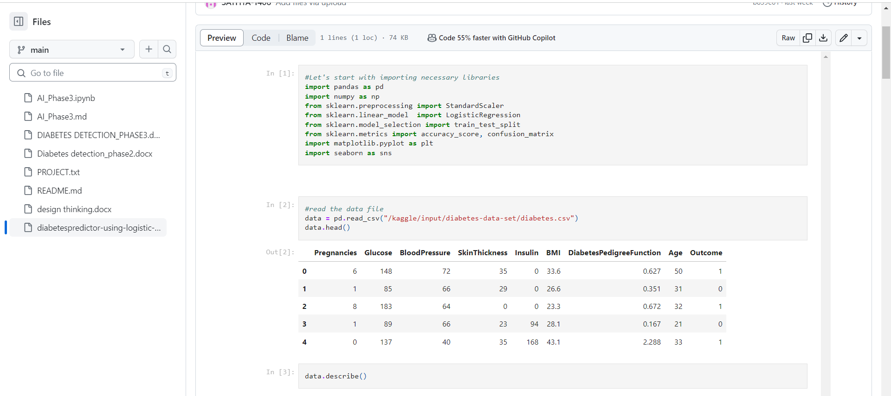

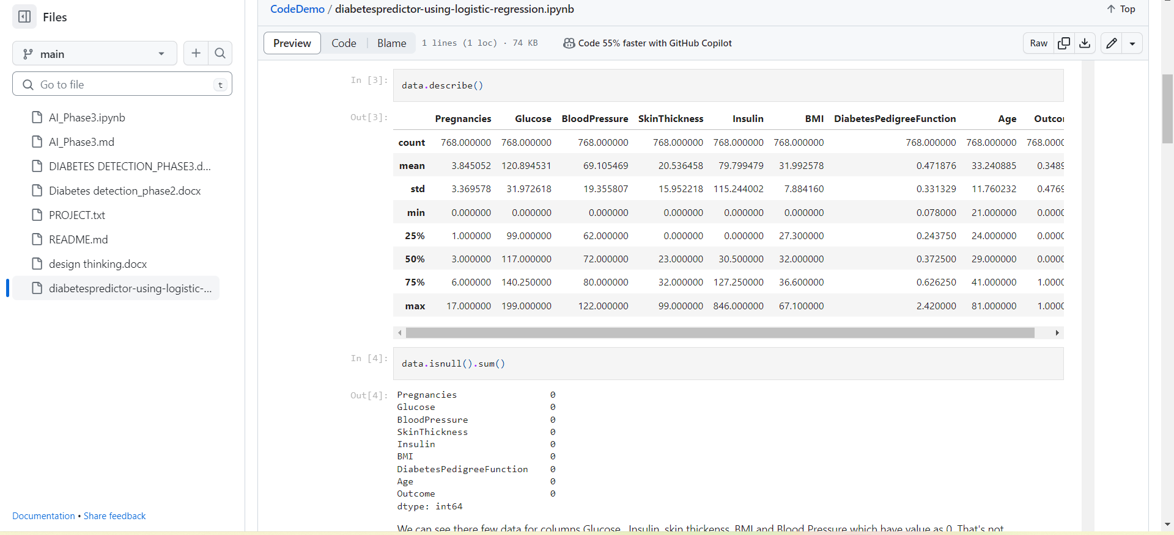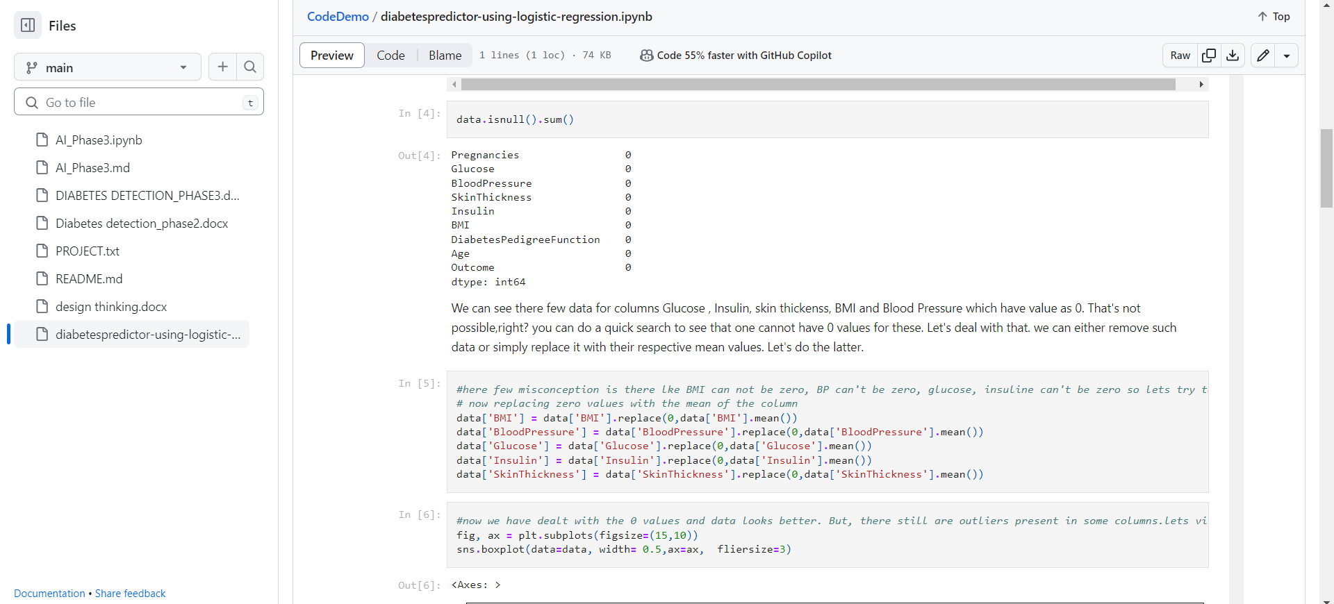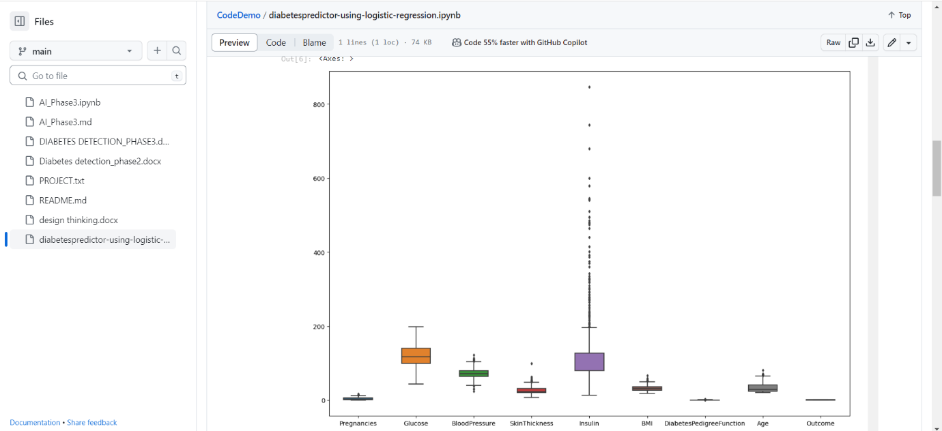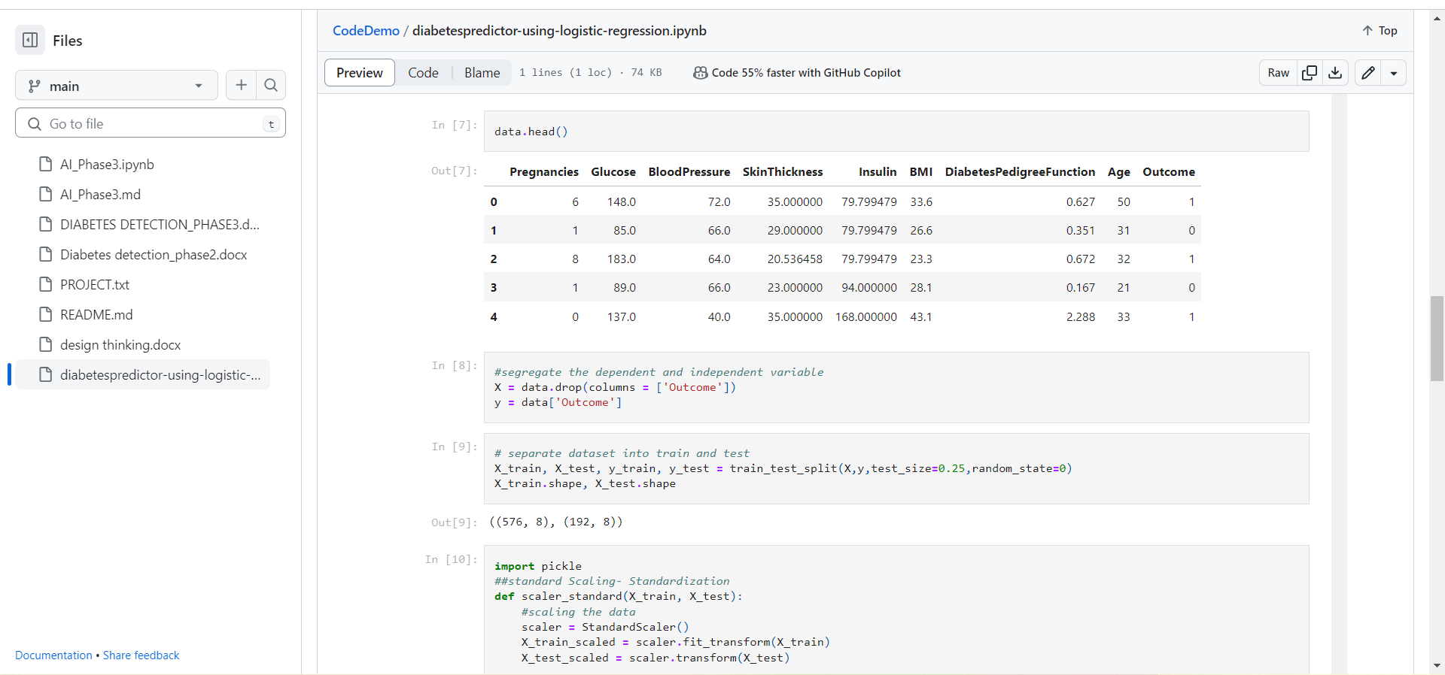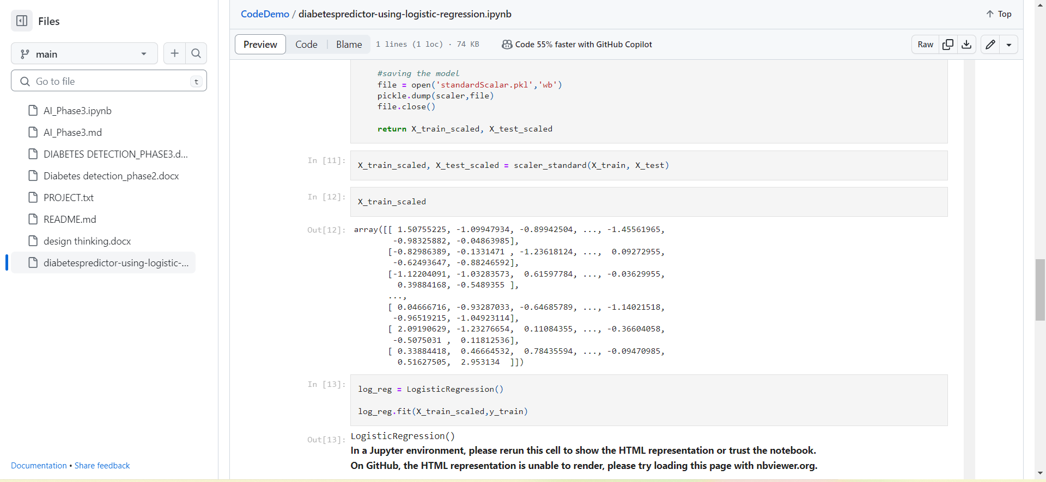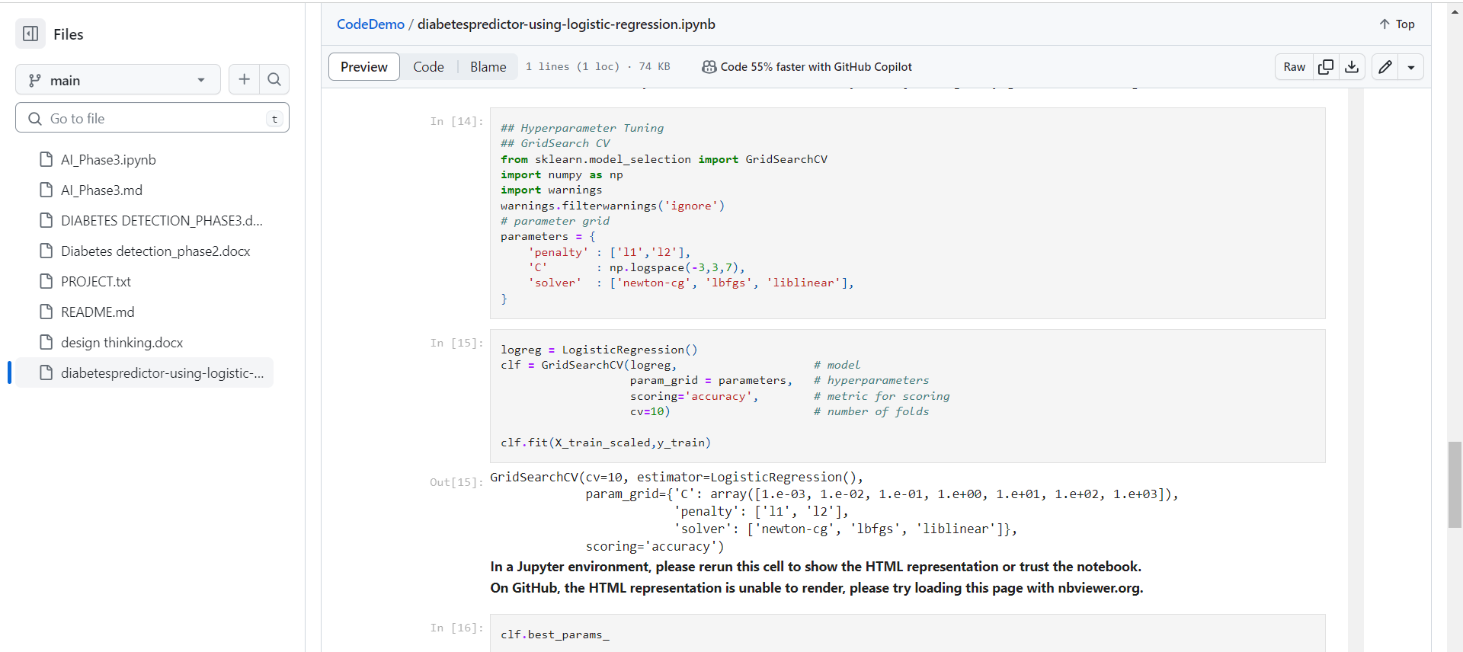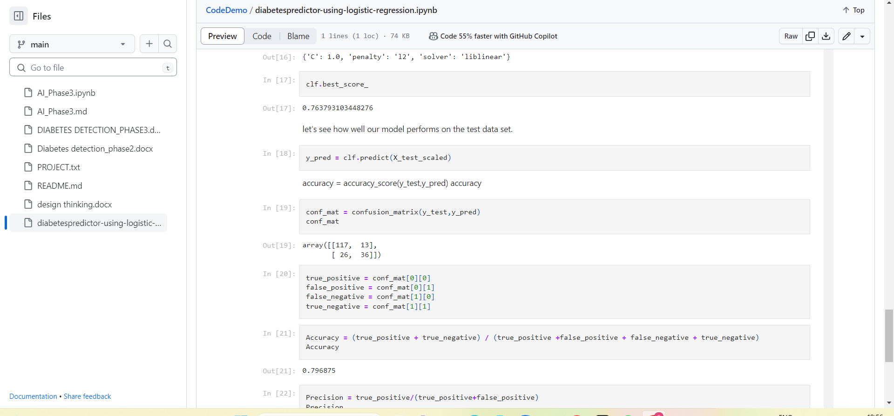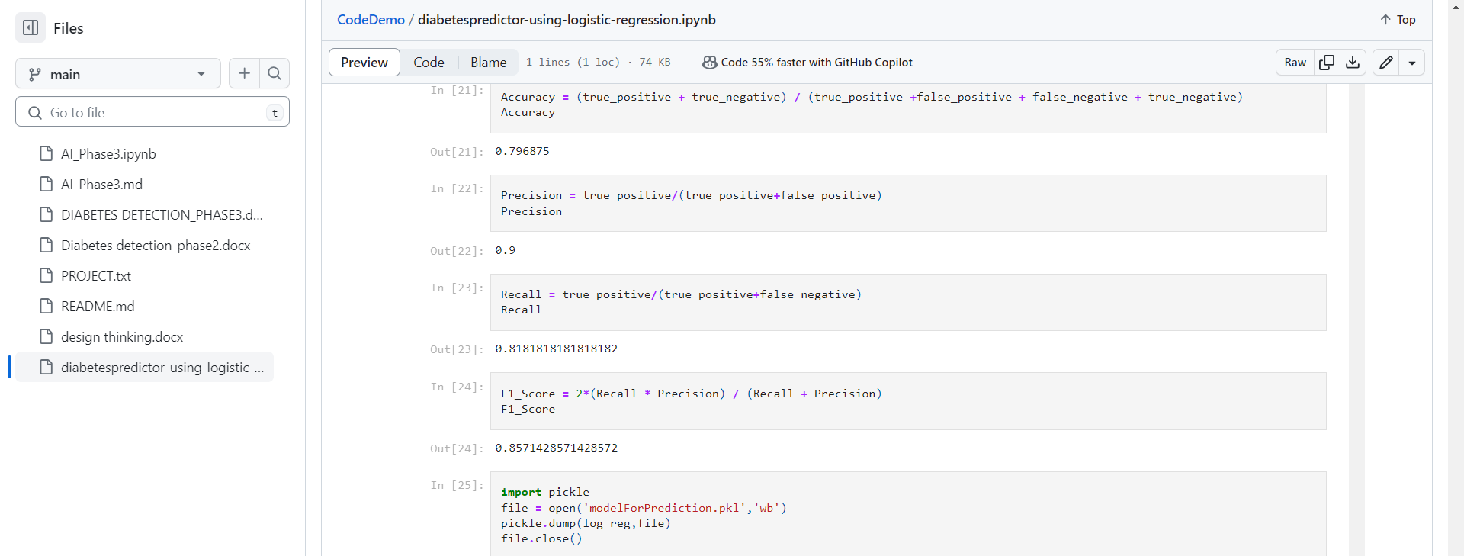

**CONCLUSION:**

By that developing a reliable AI system for medical diagnosis requires a multidisciplinary approach involving medical professionals, data scientists, and ethicists. It's crucial to ensure that the model is both accurate and safe for use in a clinical setting.